|  |
| --- |
| The SAS System |

The LOGISTIC Procedure

| **Model Information** | |
| --- | --- |
| **Data Set** | WORK.SURVIVORNORECENT |
| **Response Variable** | InvitedBack |
| **Number of Response Levels** | 2 |
| **Model** | binary logit |
| **Optimization Technique** | Fisher's scoring |

|  |  |
| --- | --- |
| **Number of Observations Read** | 615 |
| **Number of Observations Used** | 615 |

| **Response Profile** | | |
| --- | --- | --- |
| **Ordered Value** | **InvitedBack** | **Total Frequency** |
| **1** | 1 | 120 |
| **2** | 0 | 495 |

|  |
| --- |
| **Probability modeled is InvitedBack='1'.** |

| **Model Convergence Status** |
| --- |
| Convergence criterion (GCONV=1E-8) satisfied. |

| **Model Fit Statistics** | | |
| --- | --- | --- |
| **Criterion** | **Intercept Only** | **Intercept and Covariates** |
| **AIC** | 609.085 | 608.377 |
| **SC** | 613.507 | 617.221 |
| **-2 Log L** | 607.085 | 604.377 |

| **Testing Global Null Hypothesis: BETA=0** | | | |
| --- | --- | --- | --- |
| **Test** | **Chi-Square** | **DF** | **Pr > ChiSq** |
| **Likelihood Ratio** | 2.7077 | 1 | 0.0999 |
| **Score** | 2.6054 | 1 | 0.1065 |
| **Wald** | 2.5857 | 1 | 0.1078 |

| **Analysis of Maximum Likelihood Estimates** | | | | | |
| --- | --- | --- | --- | --- | --- |
| **Parameter** | **DF** | **Estimate** | **Standard Error** | **Wald Chi-Square** | **Pr > ChiSq** |
| **Intercept** | 1 | -0.8605 | 0.3554 | 5.8613 | 0.0155 |
| **Age** | 1 | -0.0169 | 0.0105 | 2.5857 | 0.1078 |

| **Odds Ratio Estimates** | | | |
| --- | --- | --- | --- |
| **Effect** | **Point Estimate** | **95% Wald Confidence Limits** | |
| **Age** | 0.983 | 0.963 | 1.004 |

| **Association of Predicted Probabilities and Observed Responses** | | | |
| --- | --- | --- | --- |
| **Percent Concordant** | 52.2 | **Somers' D** | 0.080 |
| **Percent Discordant** | 44.2 | **Gamma** | 0.083 |
| **Percent Tied** | 3.6 | **Tau-a** | 0.025 |
| **Pairs** | 59400 | **c** | 0.540 |

|  |
| --- |
| The SAS System |

The LOGISTIC Procedure

| **Model Information** | |
| --- | --- |
| **Data Set** | WORK.SURVIVORNORECENT |
| **Response Variable** | InvitedBack |
| **Number of Response Levels** | 2 |
| **Model** | binary logit |
| **Optimization Technique** | Fisher's scoring |

|  |  |
| --- | --- |
| **Number of Observations Read** | 615 |
| **Number of Observations Used** | 615 |

| **Response Profile** | | |
| --- | --- | --- |
| **Ordered Value** | **InvitedBack** | **Total Frequency** |
| **1** | 1 | 120 |
| **2** | 0 | 495 |

|  |
| --- |
| **Probability modeled is InvitedBack='1'.** |

| **Model Convergence Status** |
| --- |
| Convergence criterion (GCONV=1E-8) satisfied. |

| **Model Fit Statistics** | | |
| --- | --- | --- |
| **Criterion** | **Intercept Only** | **Intercept and Covariates** |
| **AIC** | 609.085 | 566.985 |
| **SC** | 613.507 | 575.829 |
| **-2 Log L** | 607.085 | 562.985 |

| **Testing Global Null Hypothesis: BETA=0** | | | |
| --- | --- | --- | --- |
| **Test** | **Chi-Square** | **DF** | **Pr > ChiSq** |
| **Likelihood Ratio** | 44.0999 | 1 | <.0001 |
| **Score** | 42.0111 | 1 | <.0001 |
| **Wald** | 38.7705 | 1 | <.0001 |

| **Analysis of Maximum Likelihood Estimates** | | | | | |
| --- | --- | --- | --- | --- | --- |
| **Parameter** | **DF** | **Estimate** | **Standard Error** | **Wald Chi-Square** | **Pr > ChiSq** |
| **Intercept** | 1 | -0.2688 | 0.1929 | 1.9415 | 0.1635 |
| **Placement** | 1 | -0.1356 | 0.0218 | 38.7705 | <.0001 |

| **Odds Ratio Estimates** | | | |
| --- | --- | --- | --- |
| **Effect** | **Point Estimate** | **95% Wald Confidence Limits** | |
| **Placement** | 0.873 | 0.837 | 0.911 |

| **Association of Predicted Probabilities and Observed Responses** | | | |
| --- | --- | --- | --- |
| **Percent Concordant** | 66.6 | **Somers' D** | 0.380 |
| **Percent Discordant** | 28.5 | **Gamma** | 0.400 |
| **Percent Tied** | 4.9 | **Tau-a** | 0.120 |
| **Pairs** | 59400 | **c** | 0.690 |

|  |
| --- |
| The SAS System |

The LOGISTIC Procedure

| **Model Information** | |
| --- | --- |
| **Data Set** | WORK.SURVIVORNORECENT |
| **Response Variable** | InvitedBack |
| **Number of Response Levels** | 2 |
| **Model** | binary logit |
| **Optimization Technique** | Fisher's scoring |

|  |  |
| --- | --- |
| **Number of Observations Read** | 615 |
| **Number of Observations Used** | 615 |

| **Response Profile** | | |
| --- | --- | --- |
| **Ordered Value** | **InvitedBack** | **Total Frequency** |
| **1** | 1 | 120 |
| **2** | 0 | 495 |

|  |
| --- |
| **Probability modeled is InvitedBack='1'.** |

| **Model Convergence Status** |
| --- |
| Convergence criterion (GCONV=1E-8) satisfied. |

| **Model Fit Statistics** | | |
| --- | --- | --- |
| **Criterion** | **Intercept Only** | **Intercept and Covariates** |
| **AIC** | 609.085 | 578.036 |
| **SC** | 613.507 | 586.880 |
| **-2 Log L** | 607.085 | 574.036 |

| **Testing Global Null Hypothesis: BETA=0** | | | |
| --- | --- | --- | --- |
| **Test** | **Chi-Square** | **DF** | **Pr > ChiSq** |
| **Likelihood Ratio** | 33.0487 | 1 | <.0001 |
| **Score** | 39.5534 | 1 | <.0001 |
| **Wald** | 32.4865 | 1 | <.0001 |

| **Analysis of Maximum Likelihood Estimates** | | | | | |
| --- | --- | --- | --- | --- | --- |
| **Parameter** | **DF** | **Estimate** | **Standard Error** | **Wald Chi-Square** | **Pr > ChiSq** |
| **Intercept** | 1 | -1.7457 | 0.1241 | 197.9857 | <.0001 |
| **IndImmunities** | 1 | 0.5430 | 0.0953 | 32.4865 | <.0001 |

| **Odds Ratio Estimates** | | | |
| --- | --- | --- | --- |
| **Effect** | **Point Estimate** | **95% Wald Confidence Limits** | |
| **IndImmunities** | 1.721 | 1.428 | 2.075 |

| **Association of Predicted Probabilities and Observed Responses** | | | |
| --- | --- | --- | --- |
| **Percent Concordant** | 43.6 | **Somers' D** | 0.298 |
| **Percent Discordant** | 13.8 | **Gamma** | 0.520 |
| **Percent Tied** | 42.7 | **Tau-a** | 0.094 |
| **Pairs** | 59400 | **c** | 0.649 |

|  |
| --- |
| The SAS System |

The LOGISTIC Procedure

| **Model Information** | |
| --- | --- |
| **Data Set** | WORK.SURVIVORNORECENT |
| **Response Variable** | InvitedBack |
| **Number of Response Levels** | 2 |
| **Model** | binary logit |
| **Optimization Technique** | Fisher's scoring |

|  |  |
| --- | --- |
| **Number of Observations Read** | 615 |
| **Number of Observations Used** | 615 |

| **Response Profile** | | |
| --- | --- | --- |
| **Ordered Value** | **InvitedBack** | **Total Frequency** |
| **1** | 1 | 120 |
| **2** | 0 | 495 |

|  |
| --- |
| **Probability modeled is InvitedBack='1'.** |

| **Model Convergence Status** |
| --- |
| Convergence criterion (GCONV=1E-8) satisfied. |

| **Model Fit Statistics** | | |
| --- | --- | --- |
| **Criterion** | **Intercept Only** | **Intercept and Covariates** |
| **AIC** | 609.085 | 575.957 |
| **SC** | 613.507 | 584.800 |
| **-2 Log L** | 607.085 | 571.957 |

| **Testing Global Null Hypothesis: BETA=0** | | | |
| --- | --- | --- | --- |
| **Test** | **Chi-Square** | **DF** | **Pr > ChiSq** |
| **Likelihood Ratio** | 35.1281 | 1 | <.0001 |
| **Score** | 31.4567 | 1 | <.0001 |
| **Wald** | 28.9993 | 1 | <.0001 |

| **Analysis of Maximum Likelihood Estimates** | | | | | |
| --- | --- | --- | --- | --- | --- |
| **Parameter** | **DF** | **Estimate** | **Standard Error** | **Wald Chi-Square** | **Pr > ChiSq** |
| **Intercept** | 1 | -2.7698 | 0.2932 | 89.2531 | <.0001 |
| **TC_Pct** | 1 | 0.0226 | 0.00419 | 28.9993 | <.0001 |

| **Odds Ratio Estimates** | | | |
| --- | --- | --- | --- |
| **Effect** | **Point Estimate** | **95% Wald Confidence Limits** | |
| **TC_Pct** | 1.023 | 1.014 | 1.031 |

| **Association of Predicted Probabilities and Observed Responses** | | | |
| --- | --- | --- | --- |
| **Percent Concordant** | 63.2 | **Somers' D** | 0.322 |
| **Percent Discordant** | 31.0 | **Gamma** | 0.342 |
| **Percent Tied** | 5.9 | **Tau-a** | 0.101 |
| **Pairs** | 59400 | **c** | 0.661 |

|  |
| --- |
| The SAS System |

The LOGISTIC Procedure

| **Model Information** | |
| --- | --- |
| **Data Set** | WORK.SURVIVORNORECENT |
| **Response Variable** | InvitedBack |
| **Number of Response Levels** | 2 |
| **Model** | binary logit |
| **Optimization Technique** | Fisher's scoring |

|  |  |
| --- | --- |
| **Number of Observations Read** | 615 |
| **Number of Observations Used** | 615 |

| **Response Profile** | | |
| --- | --- | --- |
| **Ordered Value** | **InvitedBack** | **Total Frequency** |
| **1** | 1 | 120 |
| **2** | 0 | 495 |

|  |
| --- |
| **Probability modeled is InvitedBack='1'.** |

| **Model Convergence Status** |
| --- |
| Convergence criterion (GCONV=1E-8) satisfied. |

| **Model Fit Statistics** | | |
| --- | --- | --- |
| **Criterion** | **Intercept Only** | **Intercept and Covariates** |
| **AIC** | 609.085 | 604.977 |
| **SC** | 613.507 | 613.820 |
| **-2 Log L** | 607.085 | 600.977 |

| **Testing Global Null Hypothesis: BETA=0** | | | |
| --- | --- | --- | --- |
| **Test** | **Chi-Square** | **DF** | **Pr > ChiSq** |
| **Likelihood Ratio** | 6.1080 | 1 | 0.0135 |
| **Score** | 7.5256 | 1 | 0.0061 |
| **Wald** | 6.2565 | 1 | 0.0124 |

| **Analysis of Maximum Likelihood Estimates** | | | | | |
| --- | --- | --- | --- | --- | --- |
| **Parameter** | **DF** | **Estimate** | **Standard Error** | **Wald Chi-Square** | **Pr > ChiSq** |
| **Intercept** | 1 | -1.4762 | 0.1058 | 194.7379 | <.0001 |
| **Idol_Score** | 1 | 0.0567 | 0.0227 | 6.2565 | 0.0124 |

| **Odds Ratio Estimates** | | | |
| --- | --- | --- | --- |
| **Effect** | **Point Estimate** | **95% Wald Confidence Limits** | |
| **Idol_Score** | 1.058 | 1.012 | 1.106 |

| **Association of Predicted Probabilities and Observed Responses** | | | |
| --- | --- | --- | --- |
| **Percent Concordant** | 19.0 | **Somers' D** | 0.108 |
| **Percent Discordant** | 8.2 | **Gamma** | 0.395 |
| **Percent Tied** | 72.8 | **Tau-a** | 0.034 |
| **Pairs** | 59400 | **c** | 0.554 |

|  |
| --- |
| The SAS System |

The LOGISTIC Procedure

| **Model Information** | |
| --- | --- |
| **Data Set** | WORK.SURVIVORNORECENT |
| **Response Variable** | InvitedBack |
| **Number of Response Levels** | 2 |
| **Model** | binary logit |
| **Optimization Technique** | Fisher's scoring |

|  |  |
| --- | --- |
| **Number of Observations Read** | 615 |
| **Number of Observations Used** | 615 |

| **Response Profile** | | |
| --- | --- | --- |
| **Ordered Value** | **InvitedBack** | **Total Frequency** |
| **1** | 1 | 120 |
| **2** | 0 | 495 |

|  |
| --- |
| **Probability modeled is InvitedBack='1'.** |

| **Model Convergence Status** |
| --- |
| Convergence criterion (GCONV=1E-8) satisfied. |

| **Model Fit Statistics** | | |
| --- | --- | --- |
| **Criterion** | **Intercept Only** | **Intercept and Covariates** |
| **AIC** | 609.085 | 563.720 |
| **SC** | 613.507 | 572.563 |
| **-2 Log L** | 607.085 | 559.720 |

| **Testing Global Null Hypothesis: BETA=0** | | | |
| --- | --- | --- | --- |
| **Test** | **Chi-Square** | **DF** | **Pr > ChiSq** |
| **Likelihood Ratio** | 47.3652 | 1 | <.0001 |
| **Score** | 50.7764 | 1 | <.0001 |
| **Wald** | 43.4784 | 1 | <.0001 |

| **Analysis of Maximum Likelihood Estimates** | | | | | |
| --- | --- | --- | --- | --- | --- |
| **Parameter** | **DF** | **Estimate** | **Standard Error** | **Wald Chi-Square** | **Pr > ChiSq** |
| **Intercept** | 1 | -2.8658 | 0.2580 | 123.3922 | <.0001 |
| **Average_Confessional** | 1 | 0.4823 | 0.0731 | 43.4784 | <.0001 |

| **Odds Ratio Estimates** | | | |
| --- | --- | --- | --- |
| **Effect** | **Point Estimate** | **95% Wald Confidence Limits** | |
| **Average_Confessional** | 1.620 | 1.403 | 1.870 |

| **Association of Predicted Probabilities and Observed Responses** | | | |
| --- | --- | --- | --- |
| **Percent Concordant** | 69.7 | **Somers' D** | 0.404 |
| **Percent Discordant** | 29.3 | **Gamma** | 0.407 |
| **Percent Tied** | 1.0 | **Tau-a** | 0.127 |
| **Pairs** | 59400 | **c** | 0.702 |

|  |
| --- |
| The SAS System |

The REG Procedure

Model: MODEL1

Dependent Variable: InvitedBack

|  |  |
| --- | --- |
| **Number of Observations Read** | 615 |
| **Number of Observations Used** | 615 |

| **Analysis of Variance** | | | | | |
| --- | --- | --- | --- | --- | --- |
| **Source** | **DF** | **Sum of Squares** | **Mean Square** | **F Value** | **Pr > F** |
| **Model** | 1 | 6.59782 | 6.59782 | 44.94 | <.0001 |
| **Error** | 613 | 89.98755 | 0.14680 |  |  |
| **Corrected Total** | 614 | 96.58537 |  |  |  |

|  |  |  |  |
| --- | --- | --- | --- |
| **Root MSE** | 0.38314 | **R-Square** | 0.0683 |
| **Dependent Mean** | 0.19512 | **Adj R-Sq** | 0.0668 |
| **Coeff Var** | 196.36082 |  |  |

| **Parameter Estimates** | | | | | |
| --- | --- | --- | --- | --- | --- |
| **Variable** | **DF** | **Parameter Estimate** | **Standard Error** | **t Value** | **Pr > |t|** |
| **Intercept** | **1** | 0.38126 | 0.03177 | 12.00 | <.0001 |
| **Placement** | **1** | -0.01938 | 0.00289 | -6.70 | <.0001 |

|  |
| --- |
| The SAS System |

The REG Procedure

Model: MODEL1

Dependent Variable: InvitedBack

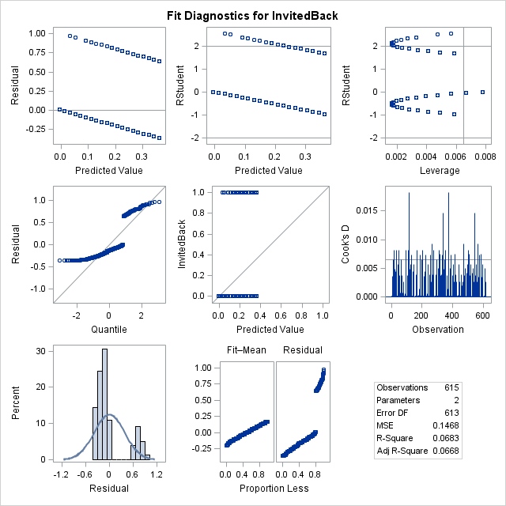

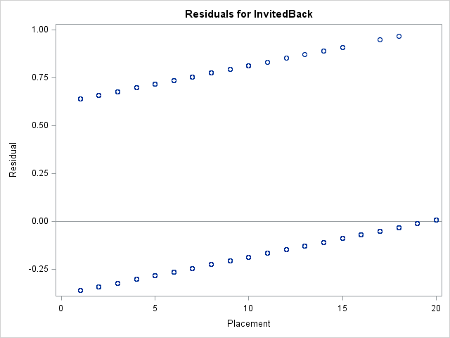

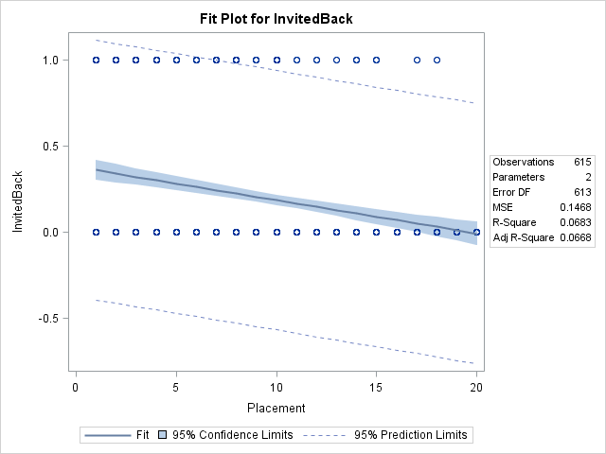

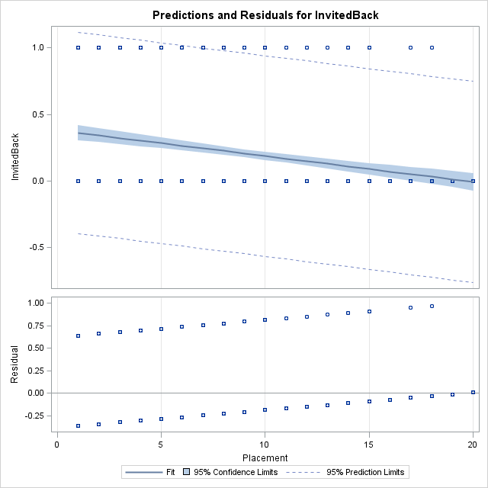

|  |
| --- |
| The SAS System |

The REG Procedure

Model: MODEL1

Dependent Variable: InvitedBack

|  |  |
| --- | --- |
| **Number of Observations Read** | 615 |
| **Number of Observations Used** | 615 |

| **Analysis of Variance** | | | | | |
| --- | --- | --- | --- | --- | --- |
| **Source** | **DF** | **Sum of Squares** | **Mean Square** | **F Value** | **Pr > F** |
| **Model** | 1 | 6.21184 | 6.21184 | 42.13 | <.0001 |
| **Error** | 613 | 90.37353 | 0.14743 |  |  |
| **Corrected Total** | 614 | 96.58537 |  |  |  |

|  |  |  |  |
| --- | --- | --- | --- |
| **Root MSE** | 0.38396 | **R-Square** | 0.0643 |
| **Dependent Mean** | 0.19512 | **Adj R-Sq** | 0.0628 |
| **Coeff Var** | 196.78150 |  |  |

| **Parameter Estimates** | | | | | |
| --- | --- | --- | --- | --- | --- |
| **Variable** | **DF** | **Parameter Estimate** | **Standard Error** | **t Value** | **Pr > |t|** |
| **Intercept** | **1** | 0.14448 | 0.01734 | 8.33 | <.0001 |
| **IndImmunities** | **1** | 0.10594 | 0.01632 | 6.49 | <.0001 |

|  |
| --- |
| The SAS System |

The REG Procedure

Model: MODEL1

Dependent Variable: InvitedBack

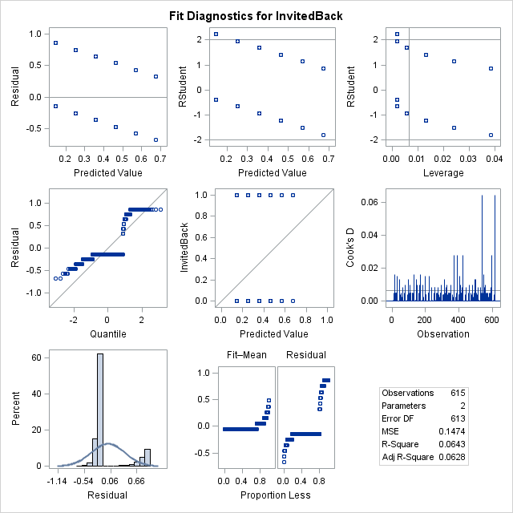

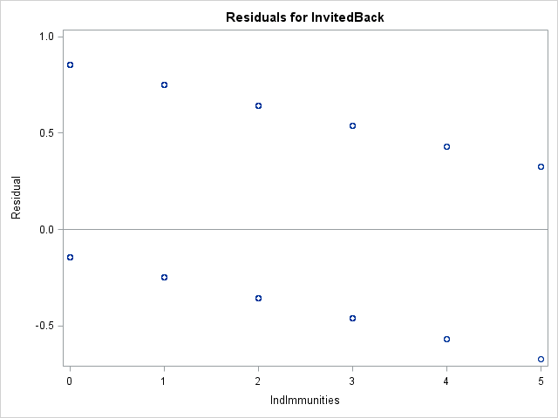

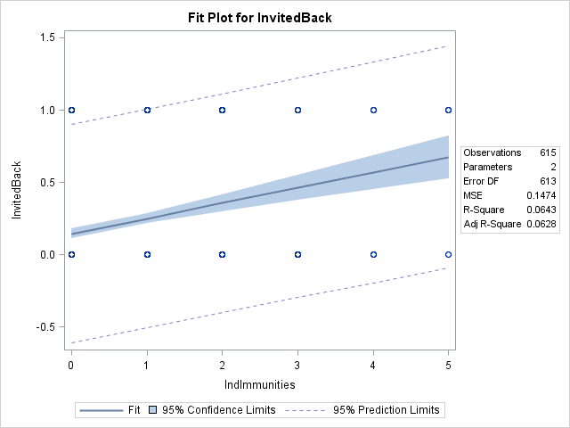

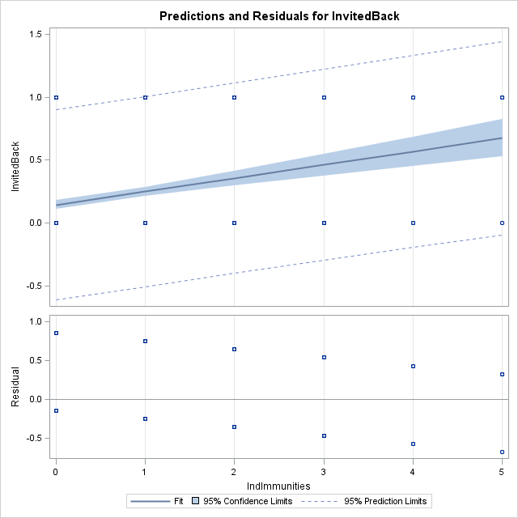

|  |
| --- |
| The SAS System |

The REG Procedure

Model: MODEL1

Dependent Variable: InvitedBack

|  |  |
| --- | --- |
| **Number of Observations Read** | 615 |
| **Number of Observations Used** | 615 |

| **Analysis of Variance** | | | | | |
| --- | --- | --- | --- | --- | --- |
| **Source** | **DF** | **Sum of Squares** | **Mean Square** | **F Value** | **Pr > F** |
| **Model** | 1 | 4.94026 | 4.94026 | 33.04 | <.0001 |
| **Error** | 613 | 91.64511 | 0.14950 |  |  |
| **Corrected Total** | 614 | 96.58537 |  |  |  |

|  |  |  |  |
| --- | --- | --- | --- |
| **Root MSE** | 0.38666 | **R-Square** | 0.0511 |
| **Dependent Mean** | 0.19512 | **Adj R-Sq** | 0.0496 |
| **Coeff Var** | 198.16104 |  |  |

| **Parameter Estimates** | | | | | |
| --- | --- | --- | --- | --- | --- |
| **Variable** | **DF** | **Parameter Estimate** | **Standard Error** | **t Value** | **Pr > |t|** |
| **Intercept** | **1** | 0.03719 | 0.03159 | 1.18 | 0.2395 |
| **TC_Pct** | **1** | 0.00293 | 0.00050999 | 5.75 | <.0001 |

|  |
| --- |
| The SAS System |

The REG Procedure

Model: MODEL1

Dependent Variable: InvitedBack

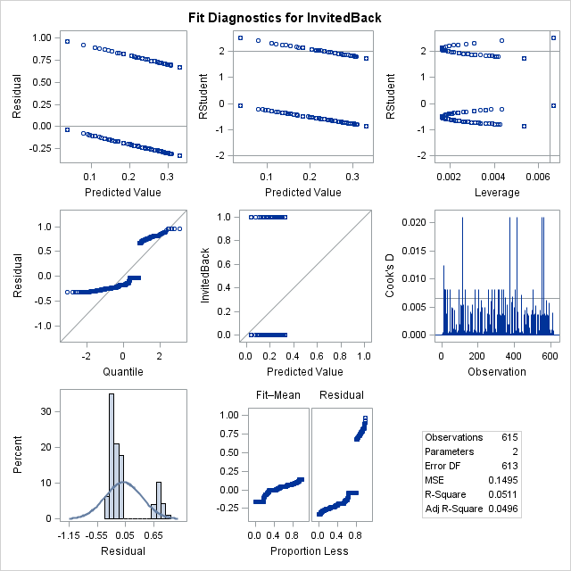

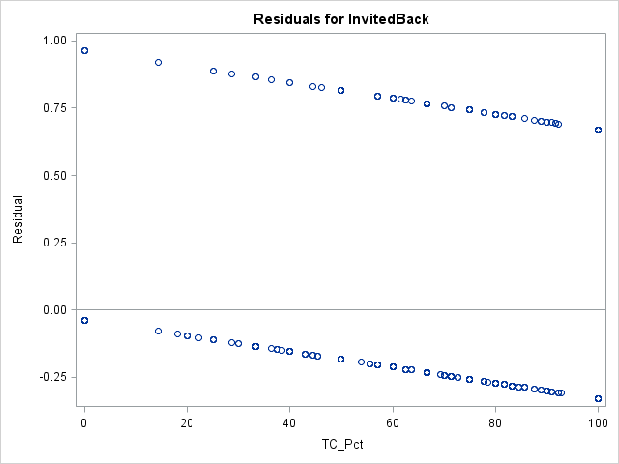

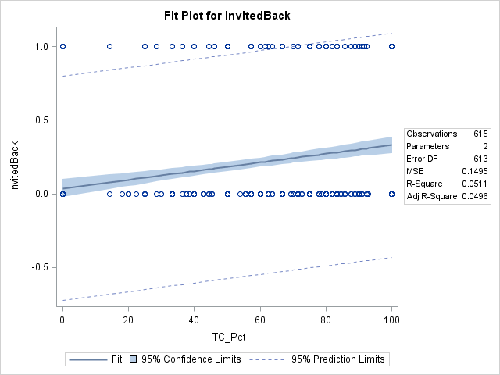

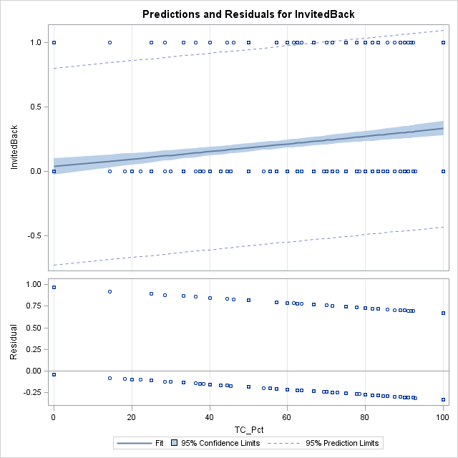

|  |
| --- |
| The SAS System |

The REG Procedure

Model: MODEL1

Dependent Variable: InvitedBack

|  |  |
| --- | --- |
| **Number of Observations Read** | 615 |
| **Number of Observations Used** | 615 |

| **Analysis of Variance** | | | | | |
| --- | --- | --- | --- | --- | --- |
| **Source** | **DF** | **Sum of Squares** | **Mean Square** | **F Value** | **Pr > F** |
| **Model** | 1 | 1.18188 | 1.18188 | 7.59 | 0.0060 |
| **Error** | 613 | 95.40348 | 0.15563 |  |  |
| **Corrected Total** | 614 | 96.58537 |  |  |  |

|  |  |  |  |
| --- | --- | --- | --- |
| **Root MSE** | 0.39450 | **R-Square** | 0.0122 |
| **Dependent Mean** | 0.19512 | **Adj R-Sq** | 0.0106 |
| **Coeff Var** | 202.18352 |  |  |

| **Parameter Estimates** | | | | | |
| --- | --- | --- | --- | --- | --- |
| **Variable** | **DF** | **Parameter Estimate** | **Standard Error** | **t Value** | **Pr > |t|** |
| **Intercept** | **1** | 0.18548 | 0.01629 | 11.39 | <.0001 |
| **Idol_Score** | **1** | 0.01158 | 0.00420 | 2.76 | 0.0060 |

|  |
| --- |
| The SAS System |

The REG Procedure

Model: MODEL1

Dependent Variable: InvitedBack

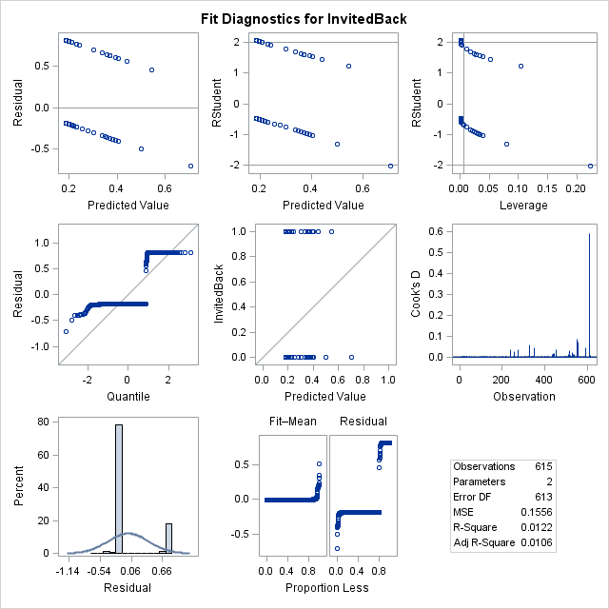

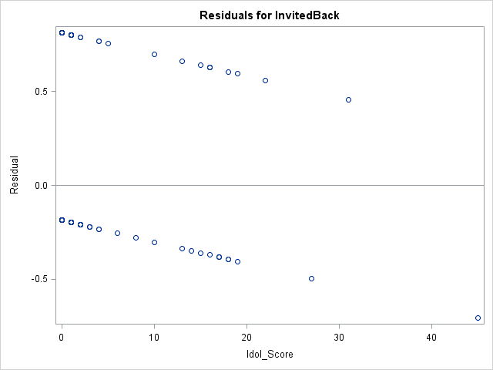

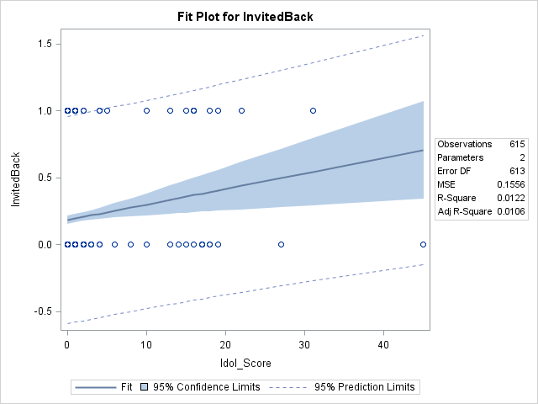

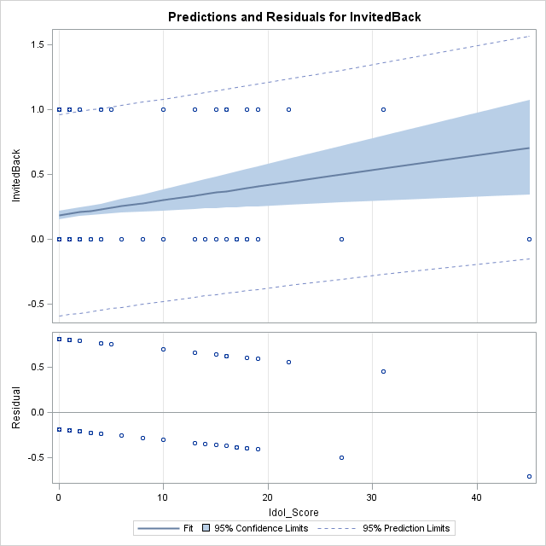

|  |
| --- |
| The SAS System |

The REG Procedure

Model: MODEL1

Dependent Variable: InvitedBack

|  |  |
| --- | --- |
| **Number of Observations Read** | 615 |
| **Number of Observations Used** | 615 |

| **Analysis of Variance** | | | | | |
| --- | --- | --- | --- | --- | --- |
| **Source** | **DF** | **Sum of Squares** | **Mean Square** | **F Value** | **Pr > F** |
| **Model** | 1 | 7.97440 | 7.97440 | 55.17 | <.0001 |
| **Error** | 613 | 88.61096 | 0.14455 |  |  |
| **Corrected Total** | 614 | 96.58537 |  |  |  |

|  |  |  |  |
| --- | --- | --- | --- |
| **Root MSE** | 0.38020 | **R-Square** | 0.0826 |
| **Dependent Mean** | 0.19512 | **Adj R-Sq** | 0.0811 |
| **Coeff Var** | 194.85312 |  |  |

| **Parameter Estimates** | | | | | |
| --- | --- | --- | --- | --- | --- |
| **Variable** | **DF** | **Parameter Estimate** | **Standard Error** | **t Value** | **Pr > |t|** |
| **Intercept** | **1** | -0.02651 | 0.03355 | -0.79 | 0.4296 |
| **Average_Confessionals** | **1** | 0.08084 | 0.01088 | 7.43 | <.0001 |

|  |
| --- |
| The SAS System |

The REG Procedure

Model: MODEL1

Dependent Variable: InvitedBack

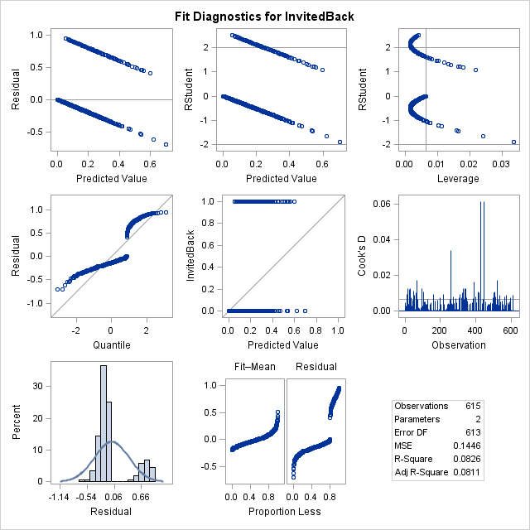

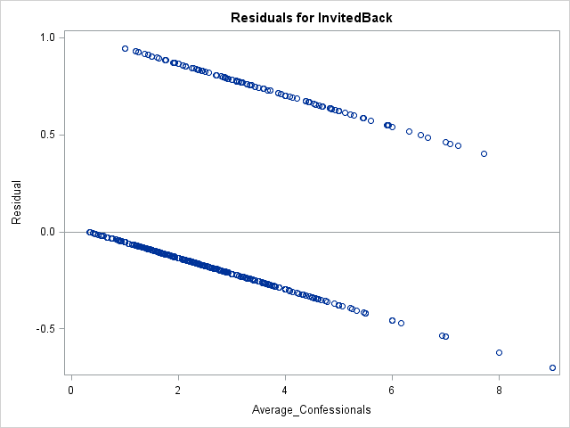

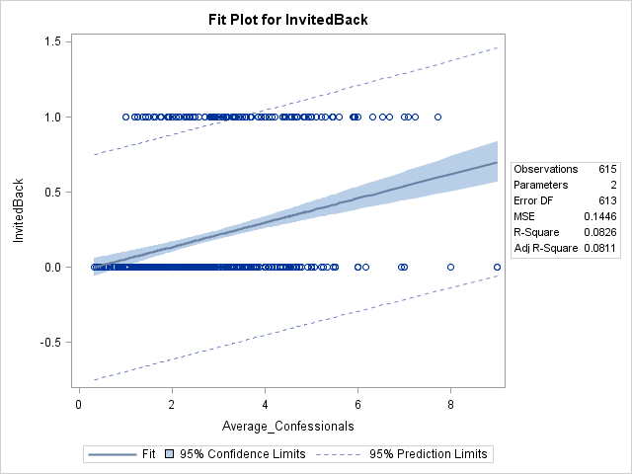

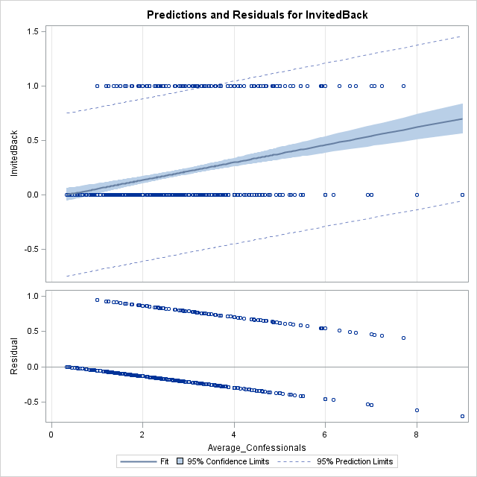

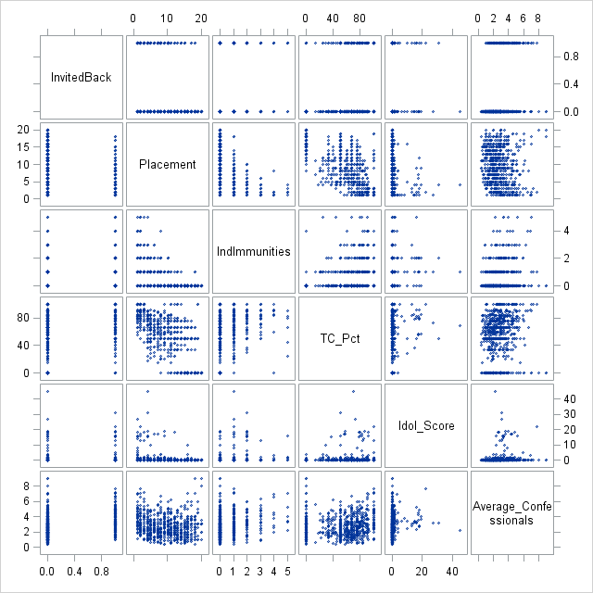

|  |
| --- |
| The SAS System |

The CORR Procedure

|  |  |
| --- | --- |
| **6 Variables:** | InvitedBack Placement IndImmunities TC_Pct Idol_Score Average_Confessionals |

| **Simple Statistics** | | | | | | |
| --- | --- | --- | --- | --- | --- | --- |
| **Variable** | **N** | **Mean** | **Std Dev** | **Sum** | **Minimum** | **Maximum** |
| **InvitedBack** | 615 | 0.19512 | 0.39662 | 120.00000 | 0 | 1.00000 |
| **Placement** | 615 | 9.60325 | 5.34802 | 5906 | 1.00000 | 20.00000 |
| **IndImmunities** | 615 | 0.47805 | 0.94942 | 294.00000 | 0 | 5.00000 |
| **TC_Pct** | 615 | 53.87091 | 30.59701 | 33131 | 0 | 100.00000 |
| **Idol_Score** | 615 | 0.83252 | 3.79004 | 512.00000 | 0 | 45.00000 |
| **Average_Confessionals** | 615 | 2.74151 | 1.40966 | 1686 | 0.33000 | 9.00000 |

| **Pearson Correlation Coefficients, N = 615  Prob > |r| under H0: Rho=0** | | | | | | |
| --- | --- | --- | --- | --- | --- | --- |
|  | **InvitedBack** | **Placement** | **IndImmunities** | **TC_Pct** | **Idol_Score** | **Average_Confessionals** |
| **InvitedBack** | |  | | --- | | 1.00000 | |  | | |  | | --- | | -0.26136 | | <.0001 | | |  | | --- | | 0.25360 | | <.0001 | | |  | | --- | | 0.22616 | | <.0001 | | |  | | --- | | 0.11062 | | 0.0060 | | |  | | --- | | 0.28734 | | <.0001 | |
| **Placement** | |  | | --- | | -0.26136 | | <.0001 | | |  | | --- | | 1.00000 | |  | | |  | | --- | | -0.52007 | | <.0001 | | |  | | --- | | -0.65254 | | <.0001 | | |  | | --- | | -0.21397 | | <.0001 | | |  | | --- | | -0.12465 | | 0.0020 | |
| **IndImmunities** | |  | | --- | | 0.25360 | | <.0001 | | |  | | --- | | -0.52007 | | <.0001 | | |  | | --- | | 1.00000 | |  | | |  | | --- | | 0.28723 | | <.0001 | | |  | | --- | | 0.19292 | | <.0001 | | |  | | --- | | 0.21859 | | <.0001 | |
| **TC_Pct** | |  | | --- | | 0.22616 | | <.0001 | | |  | | --- | | -0.65254 | | <.0001 | | |  | | --- | | 0.28723 | | <.0001 | | |  | | --- | | 1.00000 | |  | | |  | | --- | | 0.11824 | | 0.0033 | | |  | | --- | | 0.10176 | | 0.0116 | |
| **Idol_Score** | |  | | --- | | 0.11062 | | 0.0060 | | |  | | --- | | -0.21397 | | <.0001 | | |  | | --- | | 0.19292 | | <.0001 | | |  | | --- | | 0.11824 | | 0.0033 | | |  | | --- | | 1.00000 | |  | | |  | | --- | | 0.12516 | | 0.0019 | |
| **Average_Confessionals** | |  | | --- | | 0.28734 | | <.0001 | | |  | | --- | | -0.12465 | | 0.0020 | | |  | | --- | | 0.21859 | | <.0001 | | |  | | --- | | 0.10176 | | 0.0116 | | |  | | --- | | 0.12516 | | 0.0019 | | |  | | --- | | 1.00000 | |  | |

|  |
| --- |
| The SAS System |

The LOGISTIC Procedure

| **Model Information** | |
| --- | --- |
| **Data Set** | WORK.SURVIVORNORECENT |
| **Response Variable** | InvitedBack |
| **Number of Response Levels** | 2 |
| **Model** | binary logit |
| **Optimization Technique** | Fisher's scoring |

|  |  |
| --- | --- |
| **Number of Observations Read** | 615 |
| **Number of Observations Used** | 615 |

| **Response Profile** | | |
| --- | --- | --- |
| **Ordered Value** | **InvitedBack** | **Total Frequency** |
| **1** | 1 | 120 |
| **2** | 0 | 495 |

|  |
| --- |
| **Probability modeled is InvitedBack='1'.** |

| **Model Convergence Status** |
| --- |
| Convergence criterion (GCONV=1E-8) satisfied. |

| **Model Fit Statistics** | | |
| --- | --- | --- |
| **Criterion** | **Intercept Only** | **Intercept and Covariates** |
| **AIC** | 609.085 | 529.380 |
| **SC** | 613.507 | 555.910 |
| **-2 Log L** | 607.085 | 517.380 |

| **Testing Global Null Hypothesis: BETA=0** | | | |
| --- | --- | --- | --- |
| **Test** | **Chi-Square** | **DF** | **Pr > ChiSq** |
| **Likelihood Ratio** | 89.7050 | 5 | <.0001 |
| **Score** | 91.6521 | 5 | <.0001 |
| **Wald** | 72.4583 | 5 | <.0001 |

| **Analysis of Maximum Likelihood Estimates** | | | | | |
| --- | --- | --- | --- | --- | --- |
| **Parameter** | **DF** | **Estimate** | **Standard Error** | **Wald Chi-Square** | **Pr > ChiSq** |
| **Intercept** | 1 | -3.0284 | 0.6021 | 25.2969 | <.0001 |
| **Placement** | 1 | -0.0584 | 0.0315 | 3.4429 | 0.0635 |
| **IndImmunities** | 1 | 0.2036 | 0.1184 | 2.9586 | 0.0854 |
| **TC_Pct** | 1 | 0.0113 | 0.00526 | 4.5800 | 0.0323 |
| **Idol_Score** | 1 | 0.0125 | 0.0239 | 0.2735 | 0.6010 |
| **Average_Confessional** | 1 | 0.4331 | 0.0774 | 31.2862 | <.0001 |

| **Odds Ratio Estimates** | | | |
| --- | --- | --- | --- |
| **Effect** | **Point Estimate** | **95% Wald Confidence Limits** | |
| **Placement** | 0.943 | 0.887 | 1.003 |
| **IndImmunities** | 1.226 | 0.972 | 1.546 |
| **TC_Pct** | 1.011 | 1.001 | 1.022 |
| **Idol_Score** | 1.013 | 0.966 | 1.061 |
| **Average_Confessional** | 1.542 | 1.325 | 1.795 |

| **Association of Predicted Probabilities and Observed Responses** | | | |
| --- | --- | --- | --- |
| **Percent Concordant** | 75.7 | **Somers' D** | 0.519 |
| **Percent Discordant** | 23.9 | **Gamma** | 0.520 |
| **Percent Tied** | 0.4 | **Tau-a** | 0.163 |
| **Pairs** | 59400 | **c** | 0.759 |

|  |
| --- |
| The SAS System |

The LOGISTIC Procedure

| **Model Information** | |
| --- | --- |
| **Data Set** | WORK.SURVIVORNORECENT |
| **Response Variable** | InvitedBack |
| **Number of Response Levels** | 2 |
| **Model** | binary logit |
| **Optimization Technique** | Fisher's scoring |

|  |  |
| --- | --- |
| **Number of Observations Read** | 615 |
| **Number of Observations Used** | 615 |

| **Response Profile** | | |
| --- | --- | --- |
| **Ordered Value** | **InvitedBack** | **Total Frequency** |
| **1** | 1 | 120 |
| **2** | 0 | 495 |

|  |
| --- |
| **Probability modeled is InvitedBack='1'.** |

| **Model Convergence Status** |
| --- |
| Convergence criterion (GCONV=1E-8) satisfied. |

| **Model Fit Statistics** | | |
| --- | --- | --- |
| **Criterion** | **Intercept Only** | **Intercept and Covariates** |
| **AIC** | 609.085 | 527.646 |
| **SC** | 613.507 | 549.754 |
| **-2 Log L** | 607.085 | 517.646 |

| **Testing Global Null Hypothesis: BETA=0** | | | |
| --- | --- | --- | --- |
| **Test** | **Chi-Square** | **DF** | **Pr > ChiSq** |
| **Likelihood Ratio** | 89.4388 | 4 | <.0001 |
| **Score** | 91.2836 | 4 | <.0001 |
| **Wald** | 72.2399 | 4 | <.0001 |

| **Analysis of Maximum Likelihood Estimates** | | | | | |
| --- | --- | --- | --- | --- | --- |
| **Parameter** | **DF** | **Estimate** | **Standard Error** | **Wald Chi-Square** | **Pr > ChiSq** |
| **Intercept** | 1 | -2.9978 | 0.5985 | 25.0845 | <.0001 |
| **Placement** | 1 | -0.0606 | 0.0312 | 3.7766 | 0.0520 |
| **IndImmunities** | 1 | 0.2075 | 0.1179 | 3.0946 | 0.0786 |
| **TC_Pct** | 1 | 0.0112 | 0.00526 | 4.5012 | 0.0339 |
| **Average_Confessional** | 1 | 0.4352 | 0.0772 | 31.7824 | <.0001 |

| **Odds Ratio Estimates** | | | |
| --- | --- | --- | --- |
| **Effect** | **Point Estimate** | **95% Wald Confidence Limits** | |
| **Placement** | 0.941 | 0.885 | 1.001 |
| **IndImmunities** | 1.231 | 0.977 | 1.551 |
| **TC_Pct** | 1.011 | 1.001 | 1.022 |
| **Average_Confessional** | 1.545 | 1.328 | 1.798 |

| **Association of Predicted Probabilities and Observed Responses** | | | |
| --- | --- | --- | --- |
| **Percent Concordant** | 75.7 | **Somers' D** | 0.518 |
| **Percent Discordant** | 23.9 | **Gamma** | 0.521 |
| **Percent Tied** | 0.4 | **Tau-a** | 0.163 |
| **Pairs** | 59400 | **c** | 0.759 |

|  |
| --- |
| The SAS System |

| **Obs** | **Name** | **Placement** | **IndImmunities** | **TC_Pct** | **Average_Confessionals** | **predictval** |
| --- | --- | --- | --- | --- | --- | --- |
| **1** | Domenick Abbate | 2 | 3 | 80 | 4.79 | 0.61872 |
| **2** | Nick Wilson | 1 | 3 | 76.92307692 | 3.79 | 0.51875 |